Day in the Life of the Hudson River 10/14/21
Brooklyn Bridge Park Pier 4 Beach (East River)
RIVER MILE: 1.7
Salt Front: ~ 49
Christina Tobitsch & Brooklyn Bridge Park Conservancy
29 students (2nd grade) & 10 adults
Latitude & Longitude – Latitude 40.69653°N & Longitude – 73.99971°W
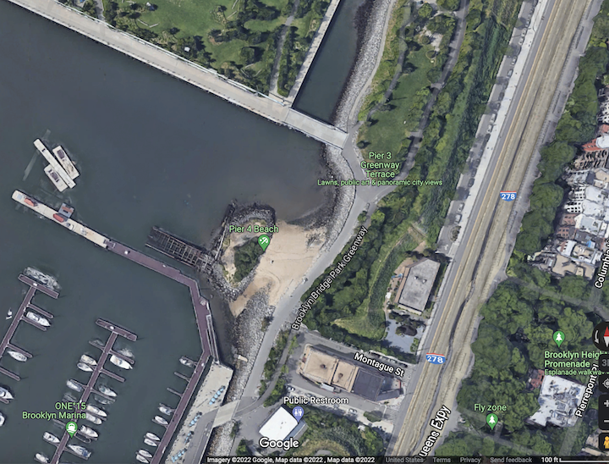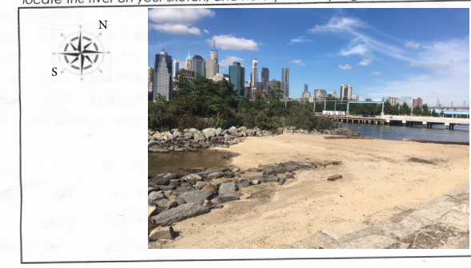
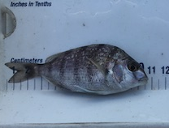 | 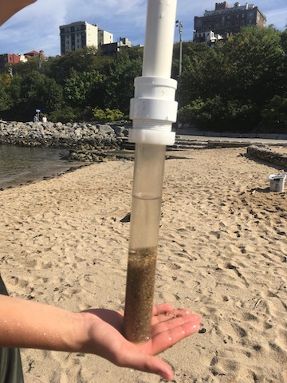 | 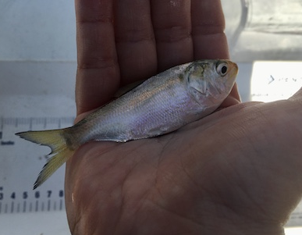

Location: Pier 4, Brooklyn Bridge Park (East River)
Area: Sandy beach peninsula
Surrounding Land Use: Urban/Residential; Beach; Park
Sampling Site: Beach; RipRap (large rocks); Pipe entering the water
Shoreline: 100% Rocky
Water: Calm
Plants in area: No plants in the area; algae
River Bottom description: Sandy and rocky
*NR = Not read/recorded
ITEM |  | Time |  | Reading |  |  |  | Comments
Physical
Air Temperature |  | 10:00 AM |  | 23.35 º C |  |  | 74º F
Wind Speed: NR |  |  |  | Anemometer |  |  | Beaufort | Direction
Weather today |  | 10:00 AM |  | <25% cloud cover |  |  | No rain
Weather the past 3 days: |  | Nothing unusual
Tides- NR |  | Time |  | Rising, Falling, Unchanged |  |  | Height (cm)
 |  | 10:00 AM |  | Rising during sampling |  |  | *LT at 10:04 AM  HT at 4:35 PM | *used tide chart
Current- NR |  | Time |  | Cm/sec |  | Knots | North/South | Ebb/Flood/Still
Water Temperature- |  | 9:45 AM  10:20 AM  11:30 AM  12:50 AM |  | 20.4º C  21.1 º C  21.1 º C  22 º C |  |  | 68.7º F  70 º F  70 º F  71.5 º F
Turbidity- Turbidimeter (NTU); Long Sight Tube |  | 9:45 AM  10:40 AM  11:54 AM  12:20 PM |  | 29 NTU  48 cm  58 cm  60 cm |  |  | Water seemed to be getting clearer as the morning progressed. Small pieces of algae in sample used.
Chemical
Salinity- meter/probe |  | 9:45 AM  10:30 AM  12:50 PM |  | 20.1 ppt  20 ppt  20.8 ppt |  |  | Probe  Hydrometer  probe
Standardized Salinity – Refractometer |  | 12:50 PM |  | 21,000 ppm |  |  | 21 ppt
DO – Meter/probe |  | Time |  | Temp |  |  | ppm DO | % Saturation
 |  | 9:45 AM  12:50 PM |  | 20.4º C  22 º C |  |  | 7.3  8.3 | 90%  120%
pH – HORIBA multi-parameter probe  *These readings are puzzling and really varied for pH? |  | 9:45 AM  12:50 PM |  | 8.6  9.7 |  |  | 10:30 am pH pen  10:30 am color match | 7.6  7.0
Nitrates- NR
Phosphates-NR
Biological
Fish - |  | Number |  | Name |  |  | Length of longest | Length of smallest
 |  | 1  13  3 |  | Atlantic Menhaden  Atlantic Silverside  Scup (porgy) |  |  | 8.5 cm  10 cm  11 cm | 1 cm (larvae stage)  10 cm
Fish Totals |  | TOTAL:  17 |  | Diversity: 3
Macroinvertebrates |  | Number |  | Name |  |  | Length of longest | Length of smallest
 |  | 1  15  1  4  1 |  | Long clawed Hermit  Crab  Ctenophore sp.  Palaemonetes Shrimp  Eastern Mud Snail  Ribbed Mussel |  |  | NR | NR
Macroinvertebrate Totals |  | TOTAL: 22 |  | Diversity: 5
Sediment Core
Length | H2S smell |  | Oxid Top |  | Oil |  | Grain Size | Other Features
10 cm | No |  | No |  | No |  | Abundant: sand  Rare: gravel | Rare: wood
Boats-NR
 | Time |  | Name |  | Color |  | North/Southbound | Light/Loaded
Commercial
Residential

